

**SHAID SMARAK COLLEGE**

Kirtipur, Kathmandu

*Assignment of Computer Fundamentals*

**Submitted by :-**

1st semester

Amir Maharjan

**Submitted to :-**

Kijush Maharjan

**GUI Based Operating System**

* **Interface**

When referring to software, an interface is a program that allows a user to interact computers in person or over a network. An interface may also refer to controls used in a program that allow the user to interact with the program. One of the best examples of an interface is a GUI (Graphical User Interface). This type of interface is what you are using now to navigate your computer. When referring to hardware, an interface is a physical device, port, or connection that interacts with the computer or other hardware device. Some examples of drive interfaces are: ATA, ATAPI, IDE, SATA, etc.

* **GUI VS CUI**

Here are some differences of GUI and CUI.

|  |  |
| --- | --- |
| **GUI** | **CUI** |
| It stands for Graphical user interface. | It stands for Command line interface. |
| It is slower compared to CUI. | It is faster. |
| It requires more memory as it contains a lot of graphical components. | It does not require more memory. |
| There are customizable options to change the appearance. | It is not possible to change the appearance. |
| It is a type of user interface that allows users to interact with electronic devices through graphical icons and visual indicators | An interface for the user to issue commands in the form of successive lines of text or command lines to perform the tasks. |

* **Introduction to Windows**

Microsoft windows is a multitasking operating system developed by Microsoft Corporation which uses Graphical User Interface to interact with the users. Microsoft was originally named “Traf-O-Data” in 1972 and was renamed to “Micro-soft” in 1975. On 1976, Microsoft entered the marketplace by releasing version 1.0 of the operating system Microsoft DOM (MS-DOS), a 16-bit command line operating system.

* **Features**

There are numerous features of windows for example: **Windows search**, we can have numerous files and contents located on our system and sometimes we may run out of memory about the exact location of our file. It is a search function included with Windows that allows user to search their entire computer. Another one of these examples are: **Windows file transfer,** we may have the need to transfer in or transfer out the files and contents from our machine to other devices such as other computers and mobiles. We can do this by using and Easy transfer cable, CDs, USB, etc.

* **Elements of Windows**

1. Title Bar

The title bar will display the name of the application and the name of the document opened. It will also contain minimize, maximize and close button.

1. Menu bar

The menu bar is seen under the title bar. Menus is the menu bar can be accessed by pressing Alt key and the letter that appears underlined in the menu title. Additionally, pressing Alt or F10 brings the focus on the first menu of the menu bar.

1. Taskbar

At the bottom of the screen is a horizontal bar called the taskbar. This bar contains (from left to right) the start button, shortcuts to various programs, minimized programs and in the extreme right corner you can see the system tray which contains of volume control, network, date and time, etc. Next to the start button is the quick launch toolbar which contains task for frequently used applications.

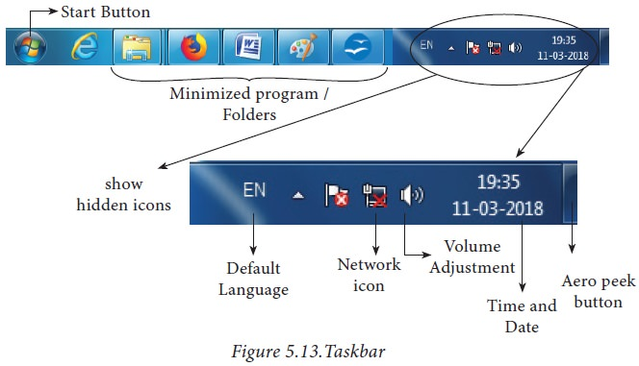

These were some elements of windows that we discussed and there are many more left.

* **Using Menus and Submenus**

Menus are hierarchical lists of commands or options available to users in the current context. Drop-down menus are menus displayed on demand on mouse clicks or hover. They are normally hidden from view and therefore are an efficient means of conserving screen space. A submenu or cascading menu is a secondary menu displayed on demand from within a menu. They are indicated by an arrow at the end of the submenu label. A menu item is an individual command or option within a menu. Menus are often displayed from menu bar, which is a list of labeled menu categories typically located near the top of a window. By contrast, a context menu drops down when users right-click on an object or window region that supports a context menu.

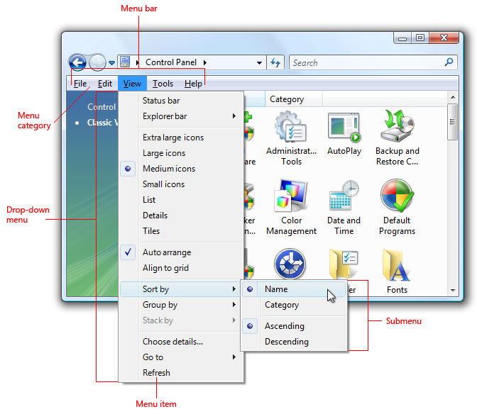

* **Opening a program and multiple programs**

Opening a program is quite a simple task in GUI based OS firstly click a tile in the start menu and click all apps button in the lower-left corner. This displays an alphabetical list of installed apps. Click an app to open it. If you want to open another app then click on another app to it as well. You can open as many app as you want but it will slow down your computer quite considerably. So, open apps that you need to.

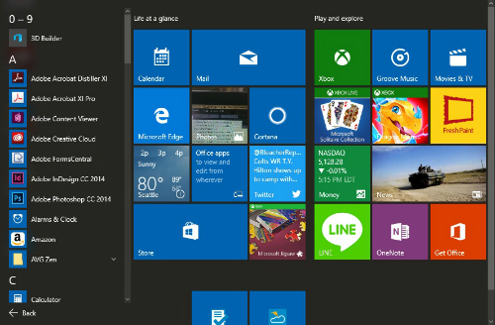

* **Using shortcuts**

Windows has provided its users with a blessing known as shortcuts. There are a lot of shortcut like ctrl+z, ctrl+c, ctrl+v, etc. The shortcuts are made in order to make the user make save time and make them more efficient. The shortcuts can vary from one app to another. The shortcuts are a real time saver and once you get used to using shortcuts, using windows will be a blast.

* **Using my computer**

The my computer icon in the desktop gives you access to all the files and folder you have saved or the files that are needed to run your computer. You can use it to save your setup files, music, videos, etc. You can also use the shortcut key windows logo key + E to open my computer directly without needing to go to your desktop to do so. This shortcut will definitely come in handy.

* **Switching off the system**

Select start and select power and shut down. Move your mouse to the lower left-hand corner of the screen and right click the start button or press windows logo key + X on your key board. Tap or click shut down or sign out and choose shut down and click the shutdown button.

* **Desktop and Custom wallpaper**

Desktop is the first thing you see when you turn on your computer and you can customize your desktop as you want. A computer screen in which icon are arranged in a manner analogous to objects on top of a desk.

The computer provides you with simple wallpapers to make it look fresher and newer, however you can customize your desktop and select a wallpaper you want to show in your desktop. To do that you can either go to setting and do so from there or right-click your mouse and select personalize, go to wallpaper and select your desired wallpaper.

* **Screen Saver**

A screen saver is an animation or image which replaces an unchanging computer display after a period of inactivity. It is a computer program that can be set to turn on after a period of user inactivity. It is used to prevent damage to older monitors but is now used as a way to prevent viewing of desktop contents while the user is away.

* **Notepad**

Notepad is a text editor included with all versions of Microsoft windows that allows you to create, open, read text files. If the file contains special formatting or is not a text file, it cannot be read in notepad.

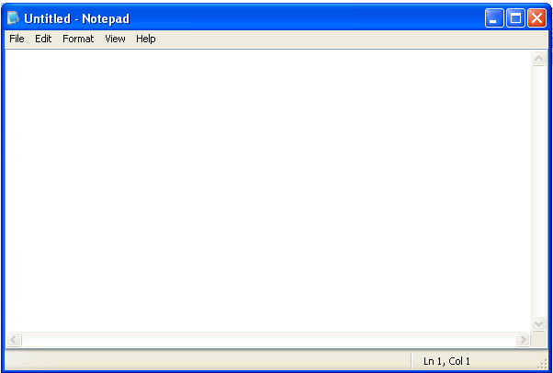

* **Paint Tool**

A painting tool is a tool or finction in a graphics editing or painting program used to change the area of the canvas or image by adding paint strokes or filling the areas with color. There are different types of paint tools here are some examples: Tools Windows, Selection tool, Move tool, View tool, etc. All these tools are given in the left side of the screen.

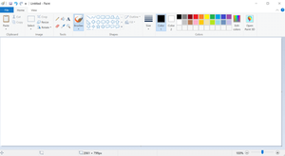

* **Clip board**

Copying images and text from one PC to another with a cloud-based clipboard. Not only can you can paste from you clipboard history, but you can also pin the item you find yourself using all the time. To get to your clipboard history at any time, prese windows logo key + V.

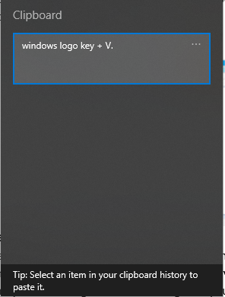

* **Character Map**

It is a utility included with windws opereting system and is used to view the characters in any installed font, to check what keyboard input (Alt code) is used to enter those characters, and to copy characters to clipboardd in lieu to typing them.

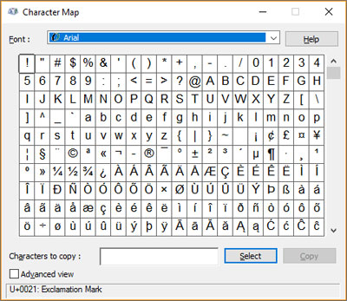

* **Calculator**

The calculator app for windows is touch-friendly version of the desktop. The calculator can help you calculate dates, convert currency, and if you’re using the standard mode, you can keep the calculator window on top of other windows.

You can open multiple calculators at the same time in resizable windows on the desktop and switch between standard , scientific, programmer, date calculation and converter modes.

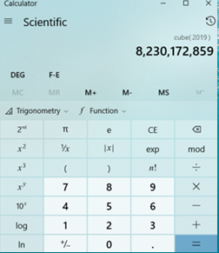

* **Using Multimedia**

Multimedia is a representation of information in an attractive and interactive manner with the use of a combination of text, audio, video, graphics and animation. In other words, we can say that Multimedia is a computerized method of presenting information combining textual data, audio, visuals (video), graphics and animations. For examples: E-Mail, Yahoo Messenger, Video Conferencing.

* **Using CD/DVD/BD**

A digital optical disc data storage format. A multimedia CD is a proposal for a new optical recording medium with a storage capacity five times higher than the conventional CD. The major part of the capacity increase is achieved by the use of optics, shorter laser wavelength an larger numerical aperture, that reduces the spot diameter by a factor 1.5.

* **Using Audio/Video**

A multimedia application may require the use of speech, music and sound effect. These are called audio or sound element of multimedia. Speech is also a perfect way for teaching. Audio are of anolog and digital types. Analog audio or sound refers to the original sound signal. Computer stores the sound in digital form.

The term video refers to the moving picture, accompained by sound such as a picture in television. Video element of multimedia application gives a lot of information in a small duration of time. Digital video is use ful in multimedia application for showing real life objects.

* **Using Explorer to manage files and folders**

File explorer is the file management application used by Windows operating system to browse folders and files. It provides a graphical interface to the user to navigate and access the files stored in the computer. The main way to access the file explorer is by clicking the folder icon in the Taskbar.



* **Copy/Delete/Rename/Short Cuts**

The copy command is used for just that. It copies the text or image you have selected and stores is on your virtual clipboard, until it is overwritten by the next “cut” or “copy” command. The shortcut to copy is Ctrl + C.

The delete function to erase the data contents of a specified field. The delete function returns the contents of the dynamic array with the specified data removed without changing the actual value of the dynamic array. The shortcut to delete is SHIFT + DELETE.

The remane function shall change the name of the file. In windows when you select a file and press the F2 key you can instantly reneme the file without having to go through the context menu.

* **Recycle bin and its uses**

The Recycle bin acts a ‘holding bay’ for deleted items, such as files and folders ( and even shortcuts). When you delete a file or folder, it is not deleted form your computer permanently. Instead, the windows places the deleted items into the recycle bin.



Uses of recycle bin are as follows:

1. Deleted files or folders are temporarily stored there.
2. Functions as a safe for items are deleted by accident.
3. You can restore deleted items.
4. The deleted items remains there until it is restored or deleted permanantely.

* **Using Format**

To format means to prepare the chosen partition on the drive to be used by an operating system by deleting all of the data an setting up a file system. Formatting does not erase the data, only the address tables. Formatting is not a 100 percent secure way to compeletely remove all data from your computer. Formatting can also have some advantages like: The document will have a clear and consistant layout, the computer will be virus free, The formatted computer will feel like a brand new computer, etc.

* **Scandisk and Disk Defragmenter**

Scandisk is a disk analysis and repair tool, first released in MS DOS, that checl a drive for errors and corrects any problem that it finds. The utility scans disk surfaces for defects and marks those sections to prevent the rewriting of data and data loss.

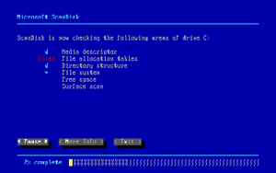

When a program saves a file on a disk, it puts the file into an empty space on the disk. Disk defragmentation takes all the pieces of each file, and stores them in one place. It also makes sure programs are each in one place, and that unused space on the hard disk is all together. Defragmenting a disk is like sorting and arranging items in a storage room. Defragmenting does not change any of the files contens and does not affect anything you see on the screen.

